A PROJECT REPORT

ON

FILE SECURITY SYSTEM USING OTP.

BACHELOR’S OF SCIENCE IN COMPUTER SCIENCE

SUBMITTED BY

Ajeet Brahmdev Jha

17040014

VIVA COLLEGE OF SCIENCE, COMMERCE AND ARTS

**PREFACE**

**It give me great pleasure to present the project on “File security system using OTP” prepared sincerely, punctually and with utmost efforts.**

**The contents of this document are presented into many chapters, in order to ease reading. This project has been illustrated with precise data elucidated with neat Data flow Diagram, Entity relationship diagram and network diagram that simplify the understanding of the project. The project includes the software development tools like ( java, MySQL , WampServer )**

**Meticulous care has been taken to make this project perfect and useful in every aspect.**

**ORGANIZATIONAL OVERVIEW**

In present day, the increasing reliance on computer systems has led to the dependence on confidential security measures. Single Sign On and Password. Password has become one of the most ubiquitous. Modern day security tool and is very commonly used for authentication. These passwords are used for authentication or user access. Access control systems require OTP. we can use a combination of two or more security processes. Two-factor authentication has ameliorated security in authentication systems. Sensitive files can be provided double protection using OTP.

Security of the computer file and folders have been a core issue ever since the advent of the windows . Passwords were then introduced to solve this issue Also we shall propose a Two Factor Authentication [T-FA] system utilizing OTP as a factor coupled with the powerful Encryption Algorithm. OTP is the most commonly used technology

**“SHA-512” The Secure Hash Algorithms** are a family of cryptographic [hash functions](https://en.wikipedia.org/wiki/Cryptographic_hash_function) published by the [National Institute of Standards and Technology](https://en.wikipedia.org/wiki/National_Institute_of_Standards_and_Technology) (NIST) as a [U.S.](https://en.wikipedia.org/wiki/United_States_of_America) Among these, SHA-256 and SHA-512 are the most commonly accepted and used hash functions computed with 32-bit and 64-bit words. Its compatibility its features etc.

It could be great breakthrough in security company .it is desktop application provided with a GUI with multiple use for the users.

**LIMITATION OF THE PRESENT SYSTEM**

1. In present days the file can be very large that is in GB it can be very difficult to store the file
2. In today system one factor authentication system (1-FA) is use of security of the file
3. When the file is not secure then anybody hack easily

**ADVANTAGES OF PROPOSED SYSTEM**

1. **E**ASY TO USE

It has user friendly GUI for using this product, no extra skill is required to use it

1. SAVE MONEY

It is an open source project, so no need to waste money on other system.

1. SPEED

Encryption and Decryption speed for file is only few second.

1. INTERNET

Internet connectivity is required for using this project.

1. FEATURES

It provide features such as “Three factor authentication”(3-FA) .

**SYSTEM REQUIREMENT SPECIFICATION**

1. **HARDWARE REQUIREMENT**
2. RAM **:** 512 MB
3. HARD DISK : MIN.20GB HDD
4. CPU SPEED : 1.4 GHZ
5. KEYBOARD
6. MOUSE
7. MONITOR
8. **SOFTWARE REQUIREMENT**
9. OPERATING SYSTEM : WINDOWS 7
10. JAVA JDK 1.4
11. NETBEANS 8.2
12. MySQL
13. WAMP SERVER

**SYSTEM ANALYSIS**

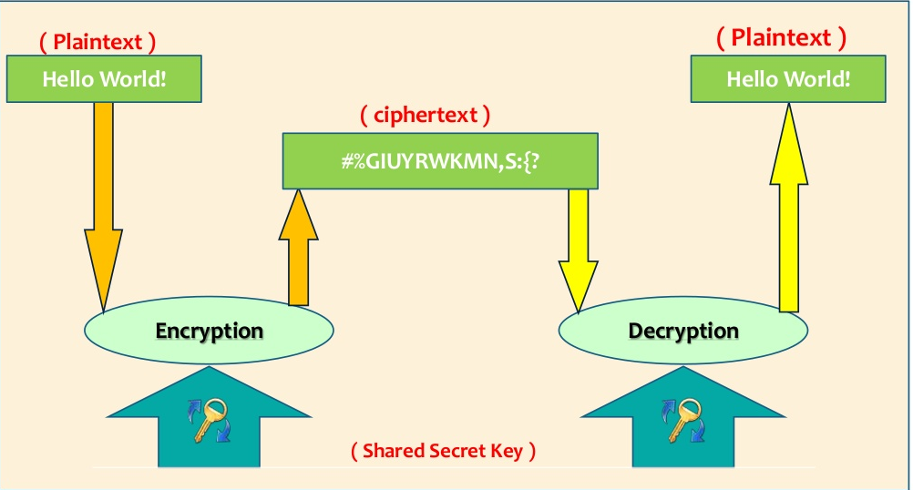

**ER DIGRAM**

**DATA FLOW DIAGRAM**

**SYSTEM DESIGN**